Devens Information sheet for Exam Wed May 26th 2021
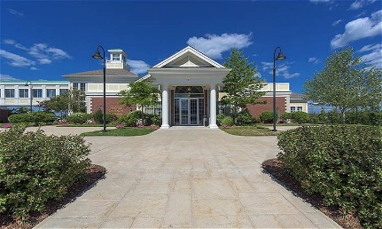

Location : 31 Andrews Parkway Devens MA 01434
Date : Wednesday May 26th 2021
Exam time:
Legal: 9:00am to 9:30am (registration to begin at 8:15am)
Practical: 10:00am to 12:30pm (registration to begin at 9:30am)
COVID/Day of Exam Protocols:
- Due to COVID-19 restrictions there will be no gathering of individuals.
- Please maintain social distance at all times.
- Masks are required at all times, even if vaccinated.
- Registration will open at 8:15 am for legal exam.
- If only sitting for practical exam, please do not enter building to register prior to 9:30am
- Once registered, please enter ballroom and pick out a seat. You will be required to sit in the same seat if taking both exams.
Other Notes:
- Coffee, Tea, bottled water and light baked goods (muffin or tea bread) will be provided
- No cell phones allowed during exams. Please ensure they are on silent mode and not used as a calculator
- Bring pencils, erasers, and non-programable calculator to exam (scrap paper will be provided)

We appreciate all of your efforts to follow the above rules and help us make this a successful exam.

Thank you

